Technical University of Cluj-Napoca

MATLAB Project

Theme: Fitness measurements

Student                                                 Coordinator

Hancis Bogdan Mihaela Cirlugea

Paul Farago

2023

**Historic** :

MATLAB was invented by mathematician and computer programmer Cleve Moler. The idea for MATLAB was based on his 1960s PhD thesis. He developed MATLAB's initial linear algebra programming in 1967 with his one-time thesis advisor, George Forsythe. This was followed by Fortran code for linear equations in 1971.

In the beginning MATLAB was not a programming language ,it was a simple interactive matrix calculator. There were no programs, no toolboxes, no graphics.

The first early version of MATLAB was completed in the late 1970s. The software was disclosed to the public for the first time in February 1979 at the Naval Postgraduate School in California. Early versions of MATLAB were simple matrix calculators with 71 pre-built functions. At the time, MATLAB was distributed for free to universities. Moler would leave copies at universities he visited and the software developed a strong following in the math departments of university campuses.

In the 1980s, Cleve Moler met John N. Little. They decided to reprogram MATLAB in C and market it for the IBM desktops that were replacing mainframe computers at the time.

**Theme**:

Fitness is a very important topic people are not talking enough these days . We should always be aware and provide ways to stay healthy , especially after the recent event of the COVID pandemic. As a sports lover , you would always want to have an idea of how your body works and ways to improve it .

Using MATLAB , it was possible to create a BMI calculator and a heart rate frequency sample .

The body mass index (BMI) is a measure that uses your height and weight to work out if your weight is healthy.

The BMI calculation divides an adult's weight in kilograms by their height in metres squared. For example, A BMI of 25 means 25kg/m2.

The formula for BMI is weight in kilograms divided by height in meters squared. If height has been measured in centimeters, divide by 100 to convert this to meters.

Heart rate is the frequency of the heartbeat measured by the number of contractions of the heart per minute. The heart rate can vary according to the body's physical needs, including the need to absorb oxygen and excrete carbon dioxide, but is also modulated by numerous factors, including (but not limited to) genetics, physical fitness, stress or psychological status, diet, drugs, hormonal status, environment, and disease/illness as well as the interaction between and among these factors. It is usually equal or close to the pulse measured at any peripheral point.

For regular heart rhythms, heart rate can easily be estimated using the large squares (0.2s) on an ECG. Simply identify two consecutive R waves and count the number of large squares between them. By dividing this number into 300 (remember, this number represents 1 minute) we are able to calculate a person’s heart rate.

BMI calculator :

When we calculate the Body mass index , it is essential to know a person’s height and weight , in Imperial or SI system.

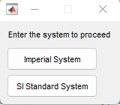

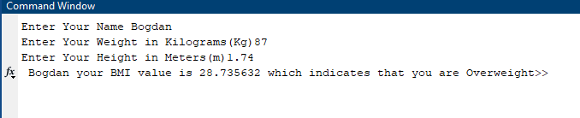

This is one example of BMI calculated using MATLAB . The results differ from person to person and usually its not the most accurate method, but these days serves as a way to improve our daily activity.

Heart beat frequency can be determined from electrocardiogram (ECG). A similar program can be created by the relation between the frequency and amplitude. The relationship between the wave's amplitude and frequency is such that it is inversely proportional to the frequency. The amplitude decreases as the frequency increases. The amplitude increases as the frequency decreases.

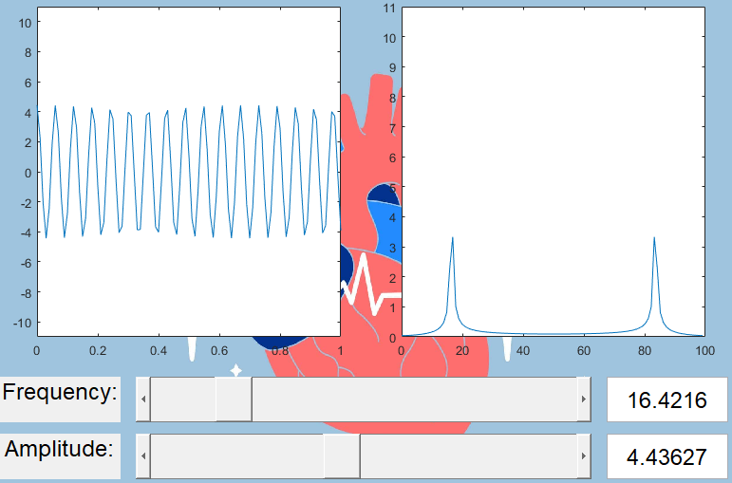

These are some examples of values and the way they respond showing us the results using graphs.

In conclusion, the BMI calculator can be a great tool indicating our body composition , it may not be always accurate, but it is an idea regarding our health. At the same time, heart rate is different from person to person , depending on different aspects like age , health diseases and so on . It is an important tool in the medical fiend and also used frequently for people who enjoy sports.

References:

https://seermedical.com/blog/calculate-heart-rate-ecg

https://www.nhs.uk/common-health-questions/lifestyle/what-is-the-body-mass-index-bmi/

https://en.wikipedia.org/wiki/MATLAB

https://en.wikipedia.org/wiki/Heart_rate

https://www.diabetes.ca/managing-my-diabetes/tools---resources/body-mass-index-(bmi)-calculator

Code used:

main.m :

Fig=figure('Name','Front',...

'Position',[300 300 300 200],...

'NumberTitle','off');

uicontrol('Style','pushbutton',...

'Units','normalized',...

'Position',[0.025 0.5 0.3 0.1],...

'BackgroundColor',[1 0 0],...

'String','Documentatie',...

'Callback','Documentatie');

uicontrol('Style','pushbutton',...

'Units','normalized',...

'Position',[0.35 0.5 0.3 0.1],...

'String','Time Frequency',...

'BackgroundColor',[0 1 0],...

'Callback','tfd_gui');

uicontrol('Style','pushbutton',...

'Units','normalized',...

'Position',[ 0.78 0.03 0.2 0.08],...

'String','Unicorn',...

'BackgroundColor',[0 1 1],...

'Callback','Unicorn');

uicontrol('Style','pushbutton',...

'Units','normalized',...

'Position',[0.67 0.5 0.3 0.1],...

'String','BMI',...

'BackgroundColor',[1 1 0],...

'Callback','Bodymassindex');

ha = axes('units','normalized', ...

'position',[0 0 1 1]);

uistack(ha,'bottom');

I=imread('BreakingDownBarriersFitness.jpg');

hi = imagesc(I);

colormap gray

set(ha,'handlevisibility','off', ...

'visible','off')

Documentatie.m:

function Documentatie

open('Documentatie.docx');

end

Bodymassindex.m :

clc

Name= input('Enter Your Name','s');

System=menu('Enter the system to proceed','Imperial System','SI Standard System');

if System==1

Weight= input('Enter Your Weight in Pounds(lbs)');

Height= input('Enter Your Height in Inches(inch)');

BMI =((Weight/(Height*Height))*703);

else

Weight= input('Enter Your Weight in Kilograms(Kg)');

Height= input('Enter Your Height in Meters(m)');

BMI =(Weight/(Height*Height));

end

if BMI<18.5

Result='Underweight';

elseif BMI>=18.5 && BMI<=24.9

Result='Normal';

elseif BMI>=25 && BMI<=29.9

Result='Overweight';

else

Result='Obese';

end

fprintf('%s your BMI value is %f which indicates that you are %s',Name,BMI,Result)

clear all

Unicorn.m:

function Unicorn

Fig=figure('Name','LPF',...

'NumberTitle','off');

w= imread('Stickers_Unicorns_Read.png');

imshow(w, 'InitialMagnification', 150);

title('LUCKY UNICORN PICTURE');

uicontrol('Style','pushbutton',...

'Units','normalized',...

'Position',[0.78 0.03 0.2 0.08],...

'String','CLOSE',...

'Callback','close;');

end

tfd_gui:

function tfd_gui()

window = figure('Color', [0.9255 0.9137 0.8471],...

'Name', ' Frequency ',...

'DockControl', 'off',...

'Units', 'Pixels',...

'Position', [100 50 800 600]);

ax1 = axes('Parent', window,...

'Units', 'normalized',...

'Position', [0.07 0.37 0.40 0.58])

ax2 = axes('Parent', window,...

'Units', 'normalized',...

'Position', [0.55 0.37 0.40 0.58])

f_slider = uicontrol('Parent', window,...

'Style', 'slider',...

'Units', 'normalized',...

'Position', [0.2 0.22 0.6 0.08],...

'Min', 0,...

'Max', 100,...

'Value', 10,...

'Callback', @updateGraph);

A_slider = uicontrol('Parent', window,...

'Style', 'slider',...

'Units', 'normalized',...

'Position', [0.2 0.12 0.6 0.08],...

'Min', 0,...

'Max', 10,...

'Value', 5,...

'Callback', @updateGraph);

f_edit = uicontrol('Parent', window,...

'Style', 'edit',...

'FontSize', 18,...

'Units', 'normalized',...

'Position', [0.82 0.22 0.16 0.08]);

A_edit = uicontrol('Parent', window,...

'Style', 'edit',...

'FontSize', 18,...

'Units', 'normalized',...

'Position', [0.82 0.12 0.16 0.08]);

f_label = uicontrol('Parent', window,...

'Style', 'text',...

'String', 'Frequency:',...

'FontSize', 18,...

'Units', 'normalized',...

'Position', [0.02 0.22 0.16 0.08]);

A_label = uicontrol('Parent', window,...

'Style', 'text',...

'String', 'Amplitude:',...

'FontSize', 18,...

'Units', 'normalized',...

'Position', [0.02 0.12 0.16 0.08]);

sin_button = uicontrol('Parent', window,...

'Style', 'pushbutton',...

'String', 'Sine',...

'FontSize', 18,...

'Units', 'normalized',...

'Position', [0.22 0.02 0.16 0.08],...

'Callback', @sinCallback);

sqr_button = uicontrol('Parent', window,...

'Style', 'pushbutton',...

'String', 'Square',...

'FontSize', 18,...

'Units', 'normalized',...

'Position', [0.42 0.02 0.16 0.08],...

'Callback', @sqrCallback);

saw_button = uicontrol('Parent', window,...

'Style', 'pushbutton',...

'String', 'Saw',...

'FontSize', 18,...

'Units', 'normalized',...

'Position', [0.62 0.02 0.16 0.08],...

'Callback', @sawCallback);

T=0.01;tmax=1;

t=0:T:tmax;

N=length(t);

fs=1/T;fax=0:fs/N:(N-1)*fs/N;

A=5;f=4;

xlabel(ax1, 'time seconds');

ylabel(ax1, 'amplitude')

title(ax1, 'Time waveform')

xlabel(ax2, 'frequency Hz');

ylabel(ax2, 'magnitude')

title(ax2, 'Magnitude Frequency Spectrum')

wave_shape = 1; % 1 is sin, 2 is squarewave, 3 is sawtooth

updateGraph()

function sinCallback(hObj, event)

wave_shape = 1;

updateGraph()

end

function sqrCallback(hObj, event)

wave_shape = 2;

updateGraph()

end

function sawCallback(hObj, event)

wave_shape = 3;

updateGraph()

end

function updateGraph(hObj, event)

f = get(f_slider, 'Value')

A = get(A_slider, 'Value')

if wave_shape == 1

x = A*cos(2*pi*f*t);

elseif wave_shape == 2

x = A*square(2*pi*f*t);

else

x = A*sawtooth(2*pi*f*t);

end

X=fft(x)/(N/2);

plot(ax1, t, x);

set(ax1, 'xlim', [0 1], 'ylim', [-11 11])

plot(ax2, fax, abs(X));

set(ax2, 'xlim', [0 100], 'ylim', [0 11])

set(f_edit, 'String', f)

set(A_edit, 'String', A)

end

ha = axes('units','normalized', ...

'position',[0 0 1 1]);

uistack(ha,'bottom');

I=imread('Heart-Rate-Variability-and-Sleep_EB-01-scaled.jpg');

hi = imagesc(I);

colormap gray

set(ha,'handlevisibility','off', ...

'visible','off')

end